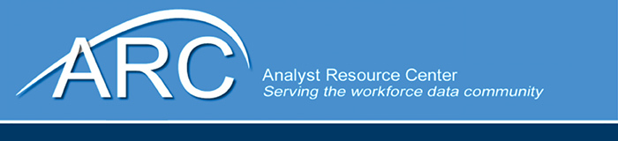

**Meeting Agenda, April 23-25, 2024**

## Royal Sonesta Dupont Circle

## Tuesday, April 23

8:30 am - Complimentary breakfast (conference room)

9:00 am - Welcome and Intros

9:30 am - ARC Update, Goals for the meeting – Bill McMahon

10:00 am - Break

10:15 am - Department of Labor Update – Don Haughton (Time TBD)

11:00 a.m.- Phil Lewis, Occupational Information Network (O*NET)

12:00 pm - Lunch break (complementary)

1:00 pm - LEWIS forum, trainings, progress and future developments – Matthew Steadman, Utah

2:00 pm - ARC Activities - Amanda Rohrer

* ARC Website
* WID 3.0 updates
* Occupational License data
* Data Axle Employer database

3:00 pm - Break

3:15 pm - Connecting the WID Database to ChatGPT/AI – Gary Sincick, Oregon

AI Use Cases and emerging state guidance (participation driven) (TBD)

State updates and presentations (TBD)

Open discussion (TBD)

4:30 pm - Adjourn

**Wednesday, April 24**

8:30 am - Complimentary breakfast (conference room)

9:00 am - AI State Survey Results

10:00 am - Measuring AI Impacts on the Labor Force – Jeff DeBellis, NC Commerce

10:45 am - Break

11:00 pm - CareerOneStop Projects – Jamie Buss, XPAND Corporation

* IPEDS and WIOA Training Programs data – Jamie Buss
* Enhanced Job Search – NLX Analytics AI Training Model

12:00 pm - Lunch break (complementary)

1:00 pm - NLX Research Hub progress and convening – Paul Daniels

1:45 pm - Texas Workforce Commission NLX Skills Analysis - Adam Leonard

2:00 pm - NLX history file benchmarking to QCEW – Amanda Rohrer (Time TBD)

2:45 pm - Break

3:00 pm - Open discussion (TBD)

3:30 pm - Updates of State AI Use Cases

4:30 pm - Adjourn

**Thursday, April 25**

8:30 am - Complimentary breakfast (conference room)

9:00 am - General meeting to cover any issues, questions, or concerns

Summary of days 1 and 2

10:15 am - Break

10:30 am - Discuss Action Items and next meeting dates and location

Wrap-up

12:00 pm - Adjourn