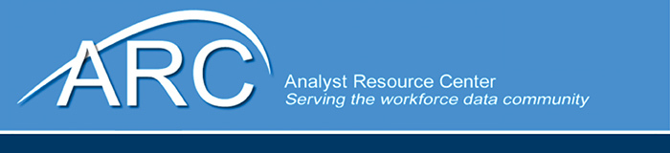

**ARC Meeting**

November 19-21, 2024

Worksystems Inc

1618 SW 1st Ave Ste 450, Portland, OR 97201

Columbia Training Room

**Tuesday, November 19**

9:30 am Welcome and Intros

Bill McMahon – structured data on job postings

Jeff DeBellis – NC – projects related to education, Model to assess scenarios for clean energy,

Bahrman – Location quotients

Kyle Davis – combined all workforce programs together to bring together all the data to track people, measure performance/outcomes

Erica, VA – Python, one page monthly report including BLS, ETA data to send to governor’s office. Ironed out some of the details.

Wayne, MI – Transition to electrical vehicles, minimum wage increase analysis, transitioning website to new format. Projections person left and I need to find out how other states do that.

Elizabeth, CO – Law around accessibility, make public facing data products accessible.

Sara McGaw, WA – product management, coordinate cross functionally, added occupational data to UI wage records, validating quality of the data as it comes in. Trying to use it to increase data quality of applicants too. Website rebuilds

Doug Jones, WA, - work with WID 3.0 database. Learning

Joe Jenky, WI, web application, wrapped up skills explorer enhancement project. Integrating COS APIs, redesigning the LMI program pages, evaluating new career clusters, working on chat bot

Heather Thomsom, WI – LPN survey, RNs and LPN take a survey, kick off in March

Steven Willowski – Python to modernize old system

Gary Sincick, OR – LMI website and support a bunch of internal applications, working on porting cite to new Linex systems to build on a new platform. Using AI to help with that. AI workgroup to establish policies around AI for agency, procurement process. County level CES estimates,

10:00 am ARC Update, Goals for the meeting – Oriane Casale

10:30 am ETA Call In – Don Haughton

11:00 am BREAK

11:15 am LEWIS Update – Matt Steadman

12:00 am Lunch on your own

1:00 pm CareerOneStop Update – Bill McMahon

1:45 pm License updates – Amanda Rohrer

2:45 pm BREAK

3:00 pm ARC Updates – Amanda Rohrer

**Wednesday, November 20**

9:00 am Member updates

Joe Jahnke, Dashboard   
Gary Sincick, small AI demo   
Kyle Davis, Python script for pywin32  
Volunteers

10:00 am BREAK

10:15 am New, Emerging, and Obsolete Occupations

Medical Assistants in NLX Data – Amanda Rohrer  
Identifying Growth Occupations for Inclusion in the SOC using Lightcast  
 – Jeff DeBellis

12:00 pm Lunch on your own

1:00 pm Partnering with Education: Projects, Approaches, and the Role of AI

Workforce Alignment and Minnesota Colleges – Carson Gorecki  
 Critical Workforce Skills for North Carolina Graduates – Jeff DeBellis

2:15 pm BREAK

2:30 pm Communications topics – two breakouts, WID/Communication

**Thursday, November 21**

9:00 am ETA and ARC Priorities Discussion as a group

10:30 am BREAK

10:45 am New Membership

11:30 am Action items

12:00 pm Adjourn